

**Citizenship, Economics and Society**

**(Secondary 1-3)**

**Support Resources**

**Secondary 1**





**Module 1.1**

**Self-understanding and Life Skills**

**Part 1:**

**Self-understanding,**

**Self-esteem and**

**Self-confidence**

(Self-learning materials included)

Personal, Social and Humanities Education Section

Curriculum Development Institute

Education Bureau

**Introduction**

* The “Citizenship, Economics and Society (Secondary1-3) Support Resources” covers the essential learning contents of Strands 1, 5 and 6 in the Personal, Social and Humanities Education Key Learning Area. It is designed to support the implementation of the Citizenship, Economics and Society curriculum.
* The support resources provide diversified learning activities to help students acquire knowledge and understand concepts, develop skills and nurture positive values and attitudes. In addition, they offer teaching guidelines and suggestions on learning and teaching activities for teachers’ reference. Further, they provide reading materials to enhance students’ interest in reading.
* “Module 1.1 Self-understanding and Life Skills Part 1: Self-understanding, Self-esteem and Self-confidence” for Secondary 1 was developed by the School of Education and Languages of the Open University of Hong Kong, commissioned by the Personal, Social and Humanities Education Section, Curriculum Development Institute of the Education Bureau.

**Module 1.1 Self-understanding and Life Skills**

**Part 1: Self-understanding, Self-esteem and Self-confidence**

**Contents**

|  |  |
| --- | --- |
|  | **Pages** |
| **Teaching Design** |  |
| Lesson 1 and Lesson 2: Understanding self-concept | 4 |
| Lesson 3 and Lesson 4: Understanding the importance of self-esteem and self-confidence for personal growth | 8 |
|  |  |
| **Learning and Teaching Activities** |  |
| Worksheet 1: Finding my true self | 13 |
| Worksheet 2: The concept of “self” | 24 |
| Worksheet 3: The importance of self-esteem for personal growth | 32 |
| Worksheet 4: The importance of self-confidence for personal growth | 43 |
|  |  |
| **Joyful Reading** |  |
| Stories of famous people | 49 |
|  |  |
| **Self-learning Materials** |  |
| Self-learning material 1: Three characteristics of self-concept | 52 |
| Self-learning material 2: The formation of self-concept | 55 |
| Self-learning material 3: Knowing “my” self-concept | 57 |
|  |  |
| **References** | 59 |

**Teaching Design:**

|  |  |  |
| --- | --- | --- |
| **Topic:** | **Self-understanding, Self-esteem and Self-confidence** | |
| **Duration:** | 4 lessons | |
| **Learning Objectives:** | * To understand self-concept: true self, ideal self and self in the eyes of others * To know the importance of self-esteem and self-confidence for personal growth * To enhance self-awareness and boosting self-esteem and self-confidence | |
| **Lesson 1 and Lesson 2 (Understanding the concept of “Self”)** | | |
| **Pre-lesson Preparation:** | Students shall finish the following before class:   * Read Worksheet 1 “Finding my true self” and Worksheet 2 “Self-concept” and finish the activities. | |
|  |  | **Suggested lesson time** |
| **Enquiry Process:** | 1. **Set:** The teacher briefly introduces the key points of learning in Lesson 1 and Lesson 2. | 5 minutes |
| 1. **Interactive teaching:**  * **Direct instruction:** The teacher briefly introduces “Activity 1: Who am I?”* in Worksheet 1. * **Pair work:** Students work in pairs and ask each other the reflective questions in Activity 1. The teacher invites several groups of students to share their answers for “Who am I” and helps students reflect on the contents. * **Direct instruction:** The teacher briefly introduces “Activity 2: The importance of knowing yourself” in Worksheet 1 and with the help of the contents of Activity 1, brings out the importance of knowing oneself and the meaning of “self-concept”. * **Student reflection:** Students finish the reflective questions in Activity 2 according to what they have learned in class and personal experience.   *\* The teacher collects students’ written work on introducing “Who I am” and their self-portraits. The teacher may consider videotaping students’ presentation for further sharing or putting up an exhibition of students’ paintings to increase learning interest and motivation.*  *\* Notes for teachers on catering for learner diversity: Activity 1 of Question 2 aims at assisting students in sorting out relevant information so that they can complete the writing activity. The teacher may decide whether to carry out this activity according to the needs of the students.*  *\* Appendix 1 “Know more: Multiple intelligences” and Appendix 2 “Know more: The self-portraits of artists” are advanced reading materials on how artists use their works to express themselves. The teacher should give some explanation during class and encourage students to finish the self-learning reading activities.*  *\* The teacher can also invite visual arts teachers to plan interdisciplinary learning activities, so that students can master the basic skills or styles of self-portrait painting to express themselves.* | 10 minutes |
| 1. **Interactive teaching:**  * **Direct instruction:** The teacher briefly introduces “Activity 3: Looking for the unique me BINGO” and the rules of the games. * **Game activities:** The teacher randomly invites students to say the adjectives that they have written down on their Bingo papers* until there is a winner. * **Class discussion:** The class as a whole discuss the questions in Activity 3 to understand that everyone is born unique and valuable. The teacher guides students to appreciate and encourage others. * **Teacher debriefing:** The teacher summarises and concludes the discussion so that students can understand their own importance and that everyone has his/her own characteristics. They should appreciate and accept their own limitations and strive to improve themselves to become better persons.   \**The teacher can choose to complete one or both games depending on the actual situation and students’ interests, lead a class discussion and make a conclusion.*  *\* Notes for teachers on catering for learner diversity: The teacher asks quiet students to answer questions or encourages students to share the less common adjectives that they have written down, to facilitate student participation.* | 15 minutes |
| 1. **Interactive teaching:**  * **Direct instruction:** The teacher briefly introduces Worksheet 2 and explains “Activity 1: Change, change, change, I have three different selves: ‘True self’, ‘self in the eyes of others’ and ‘ideal self’ in my self-concept” in Worksheet 2. * **Pair work:** Students work in pairs to discuss Activity 1 in Worksheet 2. The teacher invites several groups of students to share the results of their discussions. | 15 minutes |
| 1. **Interactive teaching:**  * **Direct instruction:** The teacher briefly introduces Activity 2 “Self in the eyes of others”. * **Student reflection:** The teacher guides students to understand the difference between “true self” and “self in the eyes of others” with the reflective questions. * **Presentation and class discussion:** The teacher invites each group to report their discussion results to the class. Based on students’ presentation, the teacher helps students deepen their understanding of “self in the eyes of others” and further consolidate their understanding of “self-concept”. | 20 minutes |
| 1. **Direct instruction and class discussion:**  * **Direct instruction:** The teacher briefly introduces “Activity 3: Ideal self: Self-portrait of my ideal self”. Before the activity, the teacher asks students to tell the class the names of their idols, and then guides students to distinguish between “true self” and “ideal self”. * **Student reflection:** The teacher guides students to understand the difference between “true self” and “ideal self” with the reflective questions to bring out the positive effects of healthy and positive attitudes on self-concept. * **Presentation and class discussion:** The teacher invites each group to report their discussion results to the class. Based on students’ presentation, the teacher helps students deepen their understanding of “ideal self” and further consolidate their understanding of “self-concept”. | 10 minutes |
| 1. **Conclusion:**  * The teacher concludes the key learning points in Lesson 1 and Lesson 2. * The teacher encourages students to appreciate others’ unique characteristics, explore their own strengths, actively overcome their limitations, and set goals towards the ideal self. * The teacher plays the “3-minute Concept” animated video clip “Self-concept” to conclude the lesson. | 5 minutes |
| **Extended Learning Activity:** | Students read Worksheet 3 “The importance of self-esteem for personal growth” and Worksheet 4 “The importance of self-confidence for personal growth” to gain initial understanding of how to become a person with self-esteem and self-confidence and the importance of such qualities for personal growth. Students are encouraged to finish Self-learning materials 1-3 by themselves. | |
| **Learning and Teaching Resources:** | Worksheets 1-2; Appendixes 1-2; Self-learning materials 1-3; “3-minute Concept” animated video clip “Self-concept” | |
| **Notes:**   * In Lesson 1 and Lesson 2, the teacher uses “Finding my true self” in Worksheet 1 and “Self-concept” in Worksheet 2 to help the students understand themselves and the meaning of “self-concept”. * Then the teacher asks students to finish Self-study Materials 1-3. | | |

|  |  |  |
| --- | --- | --- |
| **Lesson 3 and Lesson 4 (Knowing the importance of self-esteem and self-confidence for personal growth)** | | |
| **Pre-lesson Preparation:** | Students finish the following before class:   * Read Worksheet 3 “The importance of self-esteem for personal growth” and Worksheet 4 “The importance of self-confidence for personal growth”; and * Complete the relevant activities. | |
|  | | **Suggested lesson time** |
| **Enquiry Process:** | 1. **Set and revision:** The teacher briefly reviews the key learning points in Lessons 1 and Lesson 2 with students. | 5 minutes |
| 1. **Interactive teaching:**  * **Direct instruction:** The teacher briefly introduces “The importance of self-esteem for personal growth” in Worksheet 3**\*.** * **Class discussion**: The teacher invites students to share the scores they get in “Activity 1: The self-esteem scale” in Worksheet 3; and highlights that the scale is meant to help them understand themselves and the scores are not conclusive data. The teacher guides students to understand that improving self-esteem is a continuing process of self-exploration and reflection.   *\*Appendix 3 “Know more: Maslow’ s hierarchy of needs and the improvement of self-esteem” is an advanced reading material on the methods to improve self-esteem. The teacher may explain it in class and encourage students to finish the self-learning reading activity.* | 10 minutes |
| 1. **Interactive teaching:**  * **Direct instruction:** The teacher briefly introduces “Activity 2: The factors affecting self-esteem” in Worksheet 3. * **Pair work:** Students work in pairs to analyse and discuss the contents in Activity 2. The teacher invites several groups to share their discussion results. * **Teacher debriefing:** The teacher guides students to attain preliminary understanding of factors affecting self-esteem and how different innate/acquired factors affect us; and highlights that self-esteem can be constantly changed and improved. | 10 minutes |
| 1. **Interactive teaching:**  * **Direct instruction:** The teacher explains “Activity 3: Five building blocks of self-esteem” in Worksheet 3 to highlight that we can evaluate ourselves and improve our self-esteem with the five building blocks. * **Group discussion:** Divide students into groups of 4 to 5 to calculate scores for the building blocks of self-esteem for the characters in the cases and give reasons for the scores. * **Presentation and class discussion:** The teacher invites the groups to report their discussion results. Based on the presentation, the teacher helps students deepen their understanding of the five building blocks of self-esteem and their application. * **Teacher debriefing:** The teacher summarises and concludes the discussion to guide students to understand that self-esteem is affected by different factors, and inaccurate assessment of themselves will affect both their self-esteem and personal growth. The teacher highlights that it is of great importance to maintain a positive attitude and improve self-esteem with appropriate strategies. * The teacher plays the “3-minute Concept” animated video clip “Self-esteem and Self-confidence” to conclude the lesson. | 15 minutes |
| 1. **Interactive teaching:**  * **Direct instruction:** The teacher briefly introduces Worksheet 4 “The importance of self-confidence for personal growth”. * **Class discussion:** The teacher invites students to share their thoughts on “Activity 1: ‘Positivity’ and confidence” in Worksheet 4 and highlights that all positive thoughts, emotions, and behaviours are important for improving our self-confidence. * **Teacher debriefing:** The teacher asks the following question: * How to become a confident person?   Riding on the above questioning and elaboration, the teacher introduces the next part of teaching. | 10 minutes |
| 1. **Interactive teaching:**  * **Direct instruction:** The teacher introduces “Activity 2: ‘Well done’ tips”**\*.** * **Pair work:** The students work in pairs to discuss other methods to improve self-confidence according to what they have learned in class. The teacher invites several groups of the students to share their discussion results**. * **Direct instruction:** The teacher explains the methods to “be a person with self-esteem and self-confidence” and encourages the students to learn from these methods to become a person with self-esteem and self-confidence. * **Summary:** The teacher points out the importance of maintaining positive, persistent, and aspiring attitudes for the development of self-esteem and self-confidence.   ***\**** *This activity can be carried out with the help of e-learning tools (e.g., “Word Clouds”). Students can view the methods proposed by their classmates and enrich their learning.*  ***\*\**** *Appendix 4 “Know more: The bank of ‘confidence’” and Appendix 5 “Joyful Reading: Stories of famous people” are advanced reading materials on methods to improve self-confidence. The teacher gives some explanation in class and encourage students to finish the self-learning reading activities.* | 15 minutes |
| 1. **Conclusion:**  * The teacher summarises the importance of self-esteem and self-confidence for personal growth mentioned in Lesson 3 and Lesson 4. * The teacher summarises the key learning points of the whole topic. * Improving self-esteem and self-confidence is a continuing process. The teacher encourages students to appreciate themselves and others, enhance their strengths and accept their own limitations so as to cultivate and accumulate experiences for success, with the objective of working towards their ideal self, and becoming more outstanding persons in the near future. | 10 minutes |
| **Extended Learning Activity:** | The students read Appendix 3 “Know more: Maslow’s hierarchy of needs and the improvement of self-esteem”, Appendix 4 “Know more: The bank of ‘confidence’” and Appendix 5 “Joyful Reading: Stories of famous people” after class for deeper learning on improving self-esteem and self-confidence. | 5 minutes |
| **Learning and Teaching Resources:** | Worksheets 3-4; Appendixes 3-5; “3-minute Concept” animated video clip “Self-esteem and Self-confidence” | |

**Module 1.1 Self-understanding and Life Skills**

**Part 1: Self-understanding, Self-esteem and Self-confidence**

**(Lesson 1 and Lesson 2)**

**Learning and Teaching Materials**

**Preface**

Congratulations on entering a new stage of life! Psychologist Erik Erikson divided human life into eight stages, and there is a special task for each stage. The growing task for teenagers is to establish self-identity and resolve the crisis of self-identity confusion.

Truly, adolescence is a unique period in our life. During this period, we experience rapid changes in the aspects of physiology, psychology and personal relationships. We are full of joy and expectation for growth. However, at the same time, we also feel confused and perplexed. We are eager to be independent and we care about the affirmation from others. We hope that we can become adults with full control in life soon. Therefore, during this transitional period, we need to know more about ourselves, develop personal values and identities, learn to give full play to our strengths, accept limitations and overcome shortcomings so that we can establish our goals and directions.

|  |  |  |  |  |  |  |  |  |
| --- | --- | --- | --- | --- | --- | --- | --- | --- |
| Age | Birth to 1 year old | 1-3 years old | 3-6 years old | 6-11 years old | 11-18 years old | 18-30 years old | 31-50 years old | 50  years old and above |
| Stage | Infancy | Babyhood | Preschoolers | School age | Adolescence | Early adulthood | Middle adulthood | Late adulthood |

**Fig. 1 Erikson’s 8 stages of psychosocial development**

**How much do you know yourself? Is it important to know yourself? How can we get to know ourselves better?**

Source: Newman and Newman (2017), Development through life: A psychosocial approach（13th ed. ）.

**Worksheet 1: Finding my true self**

The teacher asks students to finish Worksheets 1-2 before class and then carries out a discussion and sharing activity during class.

**Activity 1: Who am I?**

1. How much do you know yourself? This activity will assist us in attaining a preliminary understanding of “Who I am”.

* Put down **key words about yourself or describing yourself** in the boxes on p.16**.** Put as many key words as you can **in 10 minutes**. If necessary, you can use an extra sheet(s) of paper to fill in more words.
* The **key words** can be your **basic personal information** (such as gender and height), **appearance, character, likes and dislikes, interests, talents** (such as academic performance, sports, artistic ability, social or other personal abilities), **strengths, weaknesses/limitations, goals**, etc. (You can put down more than one item in each category.)

Strengths and weaknesses/ limitations?

Interests?

Others?

Talents?

Appearance?

Character?



Family background?

**The multiple intelligences theory identifies the uniqueness of each person in terms of different intelligences. You can refer to Appendix 1 “Know more: Multiple intelligences” first and think about “Who I am” in accordance with the eight multiple intelligences.**



Appendix 1

**Know more: Multiple intelligences**

The theory of multiple intelligences was proposed by Howard Gardner, a professor of psychology at Harvard University, in 1995. It applied multiple approaches to find out the special talents of each person, emphasising that each person has his/her own combination of intelligences, and the aptitude of different people in different intelligences varies. For example, some people have strong sports ability, but their language ability is weak; some people have strong logic and mathematical ability, but they are not good at delivering speeches. As the saying goes, “Everyone is born with talents”. This theory reminds us that everyone has natural-born potential, and as long as we work hard, we can definitely become a person who can make a unique contribution in life.

|  |  |
| --- | --- |
| **Logical-mathematical intelligence** | The ability to effectively use numbers and logic. Persons with great logical-mathematical intelligence could be computer engineers, accountants, scientific researchers, etc. |
| **Verbal-linguistic intelligence** | Having a good command in oral and written language. Persons with great verbal-linguistic intelligence could be poets, writers, teachers, politicians, etc. |
| **Visual-spatial intelligence** | The ability to accurately feel visual space and express perceptions (images). Persons with great visual-spatial intelligence could be photographers, architects, industrial designers, etc. |
| **Bodily-kinaesthetic intelligence** | The ability to make good use of one’s own body to express ideas and feelings and produce or transform things skilfully with hands. Persons with great bodily-kinaesthetic intelligence could be dancers, athletes, actors, etc. |
| **Interpersonal intelligence** | The ability to easily recognise other people’s emotional motivations and moods. Persons with great interpersonal intelligence are sensitive to emotions and they could be practitioners, politicians, teachers, social workers etc. |
| **Intrapersonal intelligence** | Knowing their own limitations, persons with great intrapersonal intelligence will conduct self-examination by collecting opinions from various channels and accordingly they will act properly. They could be psychiatrists, philosophers etc. |
| **Musical intelligence** | The ability to keenly distinguish, change and express music. Persons with great musical intelligence could be singers, performers, etc. |
| **Naturalistic intelligence** | Being good at distinguishing, observing, classifying and experimenting various things and exploring, persons with great naturalistic intelligence could be biologists, archaeologists, etc. |

Excerpted and adapted from: 王淑俐 (2016), 《生涯發展與規劃：為職涯發展

做準備》（第三版）.

Put down **key words about yourself or describing yourself** in the following boxes and the more, the better. If necessary, you can use an extra sheet(s) of paper to fill in more words.

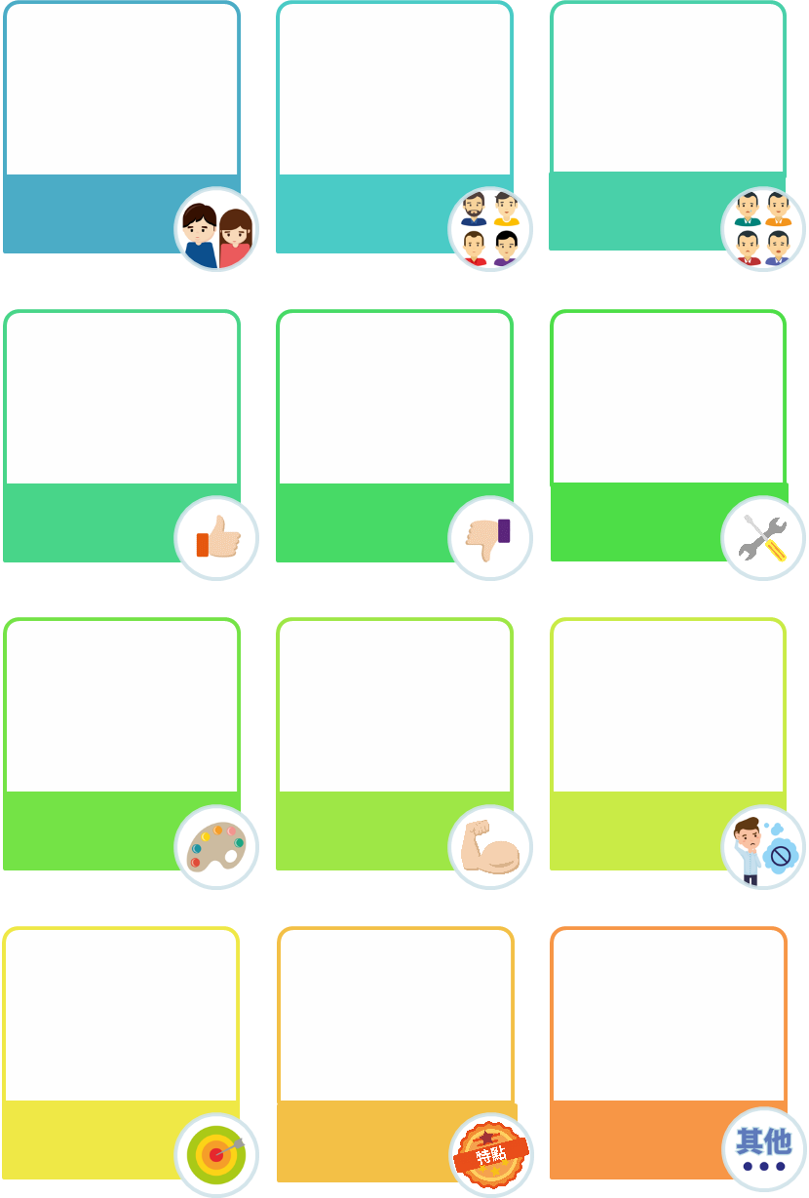

Basic personal information

Appearance

(e.g. tall)

Character

(e.g. easygoing)

Likes

(e.g. green)

Dislikes

(e.g. vegetables)

Talents

Interests

Strengths

Weaknesses/

Limitations

Goals

Characteristics

Others



1. Finish the following tasks of writing a self-introduction and painting a self-portrait according to question 1.

The teacher may ask students with higher ability to complete this part while less capable students can answer part 2 of this activity directly after they have finished question 1.

(1) My self-introduction:

* Please write a passage with at least 20 key words about yourself or describing yourself to introduce “Who I am”. After that, please circle the key words.
* You can add pictures to the passage to make it more interesting.



|  |
| --- |
| *For example:*  *My name is WONG Yat Yat, a boy, and there are three members in my family. I am the only child of my family. My face is round, and my body...*  *As to my character, I am easy-going but very shy. I like to chat and tell jokes with my friends but I don’t like to talk to strangers...*  Tips for writing:  If you put too many key points in one paragraph, it might be hard for the readers to digest them. Therefore, you should divide the whole passage into several paragraphs, with each paragraph focusing on related key points. In doing so, the structure of your passage will be clearer, which will improve the readability of the passage. |

**There is more information about the self-portraits of artists in Appendix 2 “The self-portraits of artists”**

1. My self-portrait:

* Painting a self-portrait is one way to express what you think about yourself. Try to paint a self-portrait **in pencil** by referring to the **key words about yourself or describing yourself** you have put down in this activity. Use a pencil because you will revise your self-portrait later.
* The self-portrait should be able to reflect the **key words about yourself or describing yourself**. Put down these key words in the space provided below.

|  |
| --- |
| **My self-portrait:**  This activity aims at providing opportunities for students to express what they think about themselves by painting. The teacher may invite teachers of visual arts to plan interdisciplinary activities so that students can master the basic skills of painting a self-portrait to improve their ability of self-expression. |
| **Key words about yourself or describing yourself:** |

Reflective questions:

1. Do you know yourself better after Activity 1? If yes, in which aspect(s)? If no, what are the reasons?

|  |
| --- |
| *For example:*   * *Yes. I usually don't have the opportunity or motivation to think about my strengths and goals. Now I know more about myself in these aspects.* * *No. I've always known myself and the contents that I wrote down in Activity 1* |

1. Do you know yourself well? Please try to provide one reason to support your answer.

|  |
| --- |
| *For example:*   * *Yes. No one knows myself better than I do.* * *No. I'm not sure about my character and ability. I don't think I know myself very well.* |

The teacher may encourage/guide students to share their views and then ask them to think about and give responses to these views.

**Know more: The self-portraits of artists**

Appendix 2

Self-portraits in art works are not only a channel for artists to present their inner consciousness and express themselves, but also a kind of self-narration to reflect their feelings. When we appreciate self-portraits, apart from appreciating the painting styles, we may also feel the painters’ moods, ideas, experiences, and their circumstances affected by the environment of that time. Self-portraits reflect the thoughts, feelings, attitudes and even lives of the painters.

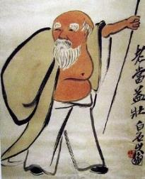

**Green Old Age by QI Baishi**

QI Baishi was a master of modern Chinese painting. He was good at painting grass, insects and flowers. The landscapes he painted were with unique styles and the characters, with their own characteristics. With his concise brushwork, his characters and attitudes were vividly portrayed with just a few audacious strokes. Green Old Age is a self-portrait painted by QI Baishi when he was 94 years old, which shows the state of physical and mental health of Mr. QI. In this painting, we can see a witty, naïve, loving and kind hero who straightens himself up with a walking stick held high, showing that he will not give in to old age and give up.

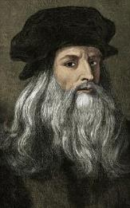

**A self-portrait of Da Vinci**

This painting was painted around 1513 and is generally believed to be the last work of Da Vinci. From this self-portrait, we can see Da Vinci’s thought and temperament in his later years and his eyes shining with wisdom. People are impressed with the lines of his long hair beard on his collar. We can feel that even though he was at his old age, his mental state was still brilliant. His nose and lips show a strong and unyielding character and willpower. This painting shows that this artist had infinite creativity and expressiveness.

**A self-portrait of Van Gogh**

Despite being one of the most outstanding artists in the 19th century, Van Gogh loved life but felt hardship as well. In this portrait, he is featured with glittering eyes, red hair, red beard, and a face with sharp corners, showing a mood of agitated depression and restlessness. From this painting, we can see his self-esteem as well as hesitation. Van Gogh began his career as a painter at the age of 27, but in the last decade of his life, he created about 2,100 paintings. Unfortunately, his works were ignored in his time, and he was trapped in mental illness and poverty. In the end he shot himself in the chest and died at the age of 37.

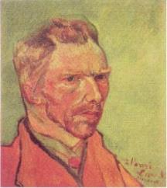

Excerpted and adapted from: 長江文藝出版社 (1982), 《藝叢》 ; 馬貝 (2018), 《繪畫大師達文西》; 宋康 (2013), 《凡高自畫像、義大利女人》.

**Activity 2: The importance of knowing yourself**

**To know oneself** means **knowing one’s “self”**. The “self” means “me” in everyday thought or speech. How we see and describe ourselves is called “**self-concept**”, which includes but is not limited to appearance (such as look and body shape), character, ability, preferences, strengths, weaknesses or limitations, family background, social role and social status. Through self-concept, we can better understand ourselves from different aspects, including awareness and understanding of our ambitions, behaviour patterns, values and our ability to influence others.

Teenagers experience rapid psychological and physiological changes at adolescence. We may feel lost and confused about the future or even feel ambivalent about ourselves. At this time, if we can grasp the opportunity to fully understand ourselves and establish a clear self-concept, we can appreciate ourselves better, accept our limitations and overcome our shortcomings. Meanwhile, a full understanding of ourselves helps us understand our own **uniqueness** and **potential**, so as to develop our strengths. When we examine ourselves, we may discover our shortcomings. Do keep in mind that you are not alone. You can turn to your teachers and peers for support and learn from them. Being willing to put ourselves in others’ shoes, accept different suggestions, and open up our mind will be of great help to understanding one’s self.

I am just an ordinary secondary school student. There is nothing unique about me!

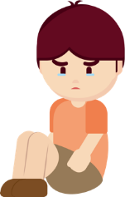

**Chi Ming**

Reflective questions:

1. Is it helpful for you to know yourself? Why?

|  |
| --- |
| *For example:*   * *Yes. It is because I can know about my character, abilities, strengths, and weaknesses, which will enable me to know my potential and plan my future goals earlier.* |

1. Do you agree with Chi Ming that there is nothing unique about ordinary people? Is there anything unique about you?

|  |
| --- |
| *For example:*   * *I agree. Ordinary people have no special strengths. How can they be unique if they are not different from others? There is nothing unique about me. I have no outstanding appearance, and I am just an average student regarding my academic achievements.* * *I disagree. Everyone is different regarding our appearance, character and thinking, and together, they make up our uniqueness. There is something unique about me because I have many characteristics that others may not have. For example, I can talk all day long without getting tired, and I can sleep in any situation.* |

**Activity 3: Looking for the unique me BINGO**

The teacher asks students to finish the chart in Game 1 below before class. During class, the teacher can choose to complete both games or only play one game according to the actual situation and students’ interests; and then carries out a class discussion and makes a conclusion.

**Game 1**

Rules:

1. Please fill in the squares according to the given tips. Don’t discuss with your classmates or let them see your information.
2. When you hear a word from your teacher that is the same as or similar to the content of one of your squares, you can mark an “X” in the square. When four squares marked with “X” form a straight line (vertical, horizontal or diagonal), you can shout “bingo” and win the game.

|  |  |  |  |
| --- | --- | --- | --- |
| Your gender | Favourite fruit | Means of going to school  (e.g. by bus, on foot) | Favourite leisure activities |
| Birthday month | Today’s hairstyle  (e.g. short hair, ponytail, curly hair) | Eye colour  (e.g. black, brown) | Number of family members |
| Sleep time at night  (e.g. 10 o’clock at night) | The class you are in | The least favourite colour | One of your strengths |
| The most satisfied body part | Foot length (cm) | Career aspiration | One of your weaknesses |

**Game 2**

**Rules:**

After playing Game 1, the teacher will give you **3** minutes to look for classmates who have written the same contents in the squares as you did and ask him/her to sign on relevant squares. The student who has most signatures will win this game.

Reflective questions:

1. Can you find a classmate who has written exactly the same contents in the 16 squares as you did? If yes, please give him/her a high-five. Do you think both of you are the same? If you can’t find one, can you explain why?

|  |
| --- |
| *For example:*   * *Yes, I can. But he/she and I just happen to share similarities in those aspects, and we still have a lot of other differences.* * *No, I can’t. Because it is hard to find someone who is totally the same as me in the world, and everyone is unique.* |

1. Please share your game paper with the classmate sitting next to you and tell him/her at least three of his/her points of uniqueness according to this game and write these down on his/her worksheet.

|  |
| --- |
| *For example:*   * *Your eyes are round; you are active; you walk fast.* |

The German philosopher Leibniz once said that “no two leaves are identical in the world”. Each one of us is unique and no two persons in the world are the same. As the saying goes, “everyone is born with talents”. It tells us that everyone is unique and valuable. Our value lies in our unlimited potential. If we accept our own limitations, strive to overcome our shortcomings, and seize opportunities to develop our strengths, we can become a better person. In addition, if we can support each other in the journey of discovering ourselves, it can help us know ourselves in a more objective and comprehensive way through learning the ideas of others. More importantly, we can also encourage and affirm each other to live a fulfilling life.

Source: 李珊 (2016), 《做一個內心豁達的女人》.

**Worksheet 2: Self-concept**

The teacher shall encourage students to study Self-learning material 1 “Three characteristics of self-concept” and Self-learning material 2 “The formation of self-concept” on their own.

**What is self-concept?**

There may be confusion or perplexity in our growth process. We may have asked ourselves what kind of a person we are. Whenever we interact with different people and have different experiences and reflections, there are new understandings and evaluations about ourselves. And gradually, we form a set of unique views on ourselves, which is called **self-concept**. In short, self-concept is about the **views that a person has on himself/herself**.

**Activity 1: Change, change, change, I have three different selves: “True self”, “self in the eyes of others” and “ideal self” in my self-concept**

**Self-concept** comprises “**true self**”, “**self in the eyes of others**” and “**ideal self**”.

**True self**

* True self refers to our views on every aspect of our own characteristics.
* These views come from comparisons with others during the process of growing up, others’ perceptions of us and different life experiences.
* ****For example, you find yourself taller than your classmates; your teachers praise you for your sense of responsibility. These will all turn into your views about yourself. Or if you often stain your clothes when you eat, you may consider yourself a careless person. In Activity 1 in Worksheet 1, you put down key words about yourself or describing yourself and these descriptions exactly belong to the “true self” part of your self-concept.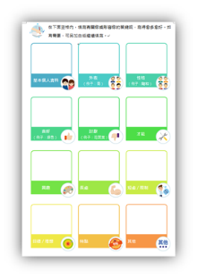

**Worksheet 1**

**Activity 1**

**Self in the eyes of others**

* Self in the eyes of others refers to others’ views on ourselves.
* 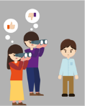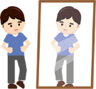Sometimes there are gaps between “true self” and “self in the eyes of others”. One of the reasons is that we tend to show the better side of ourselves to others and hide the dimmer side, worrying that others will not like us if they see our less favourable side. Besides, some of us will play a role which is preferred by others to cater others’ preferences and show the best parts of ourselves in the hope of gaining recognition from others. The two reasons mentioned above are about hiding the “true self” in order to live up to others’ expectations. Besides, there are people who are not aware of their own characteristics and only show those characteristics unintentionally when they interact with others, which will also make the “self in the eyes of others” different from the “true self”.

**Ideal self**

* Ideal self refers to the kind of person we want to be.
* The closer the “true self” is to the “ideal self”, the more satisfied we are with our own states; on the contrary, the greater the gap between the two, the more likely we will feel uneasy and depressed.
* For example, Yuen Wai hopes that she could be a sociable person. However, after entering secondary school, she always finds it difficult to start a conversation with her classmates. Due to the gap between ideal and reality, she feels depressed. However, some people will regard this as a driving force to improve and upgrade themselves and take this as an opportunity to establish their ideal selves. For example, Yuen Wai becomes more active in learning different social skills and takes the initiative to talk to her classmates.

Questions for discussion:

1. What constitutes self-concept? Try to explain the contents of each part.

|  |
| --- |
| * *Self-concept comprises “true self”, “self in the eyes of others” and “ideal self”.* * *“True self” refers to our views on own characteristics on every aspect. “Self in the eyes of others” refers to others’ views on us. “Ideal self” refers to what kind of person we want to be.* |

1. “True self” and “self in the eyes of others” are sometimes different. Please explain why it is so with an example from your experience or a friend’s experience.

|  |
| --- |
| *For example:*   * *Ka Kei thought that she was quiet and uncommunicative and would not be popular in school. But in fact, in the eyes of her classmates, Ka Kei is polite and willing to help others, and therefore all her classmates are willing to make friends with her. So, she is very popular in school.* |

1. The greater the gap between the “true self” and the “ideal self”, the more likely we will feel uneasy and depressed. Please explain why it is so with an example from

|  |
| --- |
| *For example:*   * *Ka Wah hoped that he could be good at both studies and sports. His academic achievement ranks among the tops, but his physical ability is not satisfactory. Therefore, he is far away from his ideal self, which has made him feel uneasy, depressed* *and less confident about himself.* |

Activity 2 and Activity 3 help us understand “self in the eyes of others” and “ideal self”. Now let’s continue with our self-discovery journey to deepen our self-understanding.

**Activity 2: Self in the eyes of others**

* Pre-lesson preparation:
* Please prepare **three** cards (The card sample below is for reference only. You can design your own).

**Card sample**

I am_____________________________________。

Please write down **two** of your views on me so that I can know myself better from your perspectives. Thank you!

**Signature**

＿＿＿＿＿＿ (Signature required)

1.

2.

* Before class, please invite **one family member**, **one classmate/friend** and **one person who knows you well**, such as a teacher, a neighbour, a member from the church, etc. to write down **two** of their views about you. After you get these cards back, please try to make a comparison between others’ views about you and your views about yourself that you have showed in the tasks of “My self-introduction” and “My self-portrait” in Question 2 of Activity 1 in Worksheet 1.
* If there are some **new views**, please add them to your self-introduction or self-portrait with **a red pen**.
* If there are some **new views** which **contradict** with your existing views about yourself, please **add the new views** together with question marks (?) **next to the existing views**.
* If there are views from others that are **the same** as your existing views about yourself, please mark these views with a highlighter pen.

Reflective questions:

1. If you have found some new views about yourself from the cards, please go to Question (1)(i) or (ii) and Questions 2-5. If you do not find new views about yourself from the cards, please go to Questions 3-5 directly.
2. If you agree with the new views: What are these views? Who came up with these views? Why can he/she come up with views that you did not know?

|  |
| --- |
| *For example:*   * *Yes, I agree. She is my younger sister, and she finds that I am good at taking care of others.* * *I did not notice it because we live together, and I am used to taking care of her daily life.* |

1. If you disagree with the new views: What are these views? Who came up with these views? Why would he/she have such views?

|  |
| --- |
| *For example:*   * *No, I disagree. My friend doesn’t know me well.* * *Also, I will not reveal some aspects of myself to others.* |

1. In connection to Question 1 (i): Do some of these views contradict with your existing views? If yes, refer to the following methods, how will you adjust your self-concept? Why?
2. Keep the existing views
3. Adopt new views and deny the existing ones
4. Adopt new views and keep the existing ones at the same time
5. Others (e.g. ask the person who gave the views for reasons and collect more views from other friends or family members for verification)

|  |
| --- |
| *For example:*   * *Keep the existing views. Because these are my own views and I know myself better than anyone else.* * *Adopt new views and deny the existing ones. I do not know myself very well. Many of my views about myself are just intuition without the support of concrete examples. On the contrary, views of others are more objective and comprehensive.* * *Adopt new views and keep the existing ones at the same time. Because from others’ eyes, I can recognise the other side of myself. And I think that people will show different sides of themselves in different situations, so both views can represent me.* * *Ask the person who gave the views for reasons. Because I have not noticed that side of myself before and would like to know how he/she has come to know that. And then I will ask other friends about these views because it will be very subjective if only one person’s views are considered. I will have a more objective understanding of myself if I ask more people about it.* |

1. If there are views from others that are the same as your existing views: How many of them are the same? What are these same views? What does this reflect?

If views from others are different from your existing views: What does this reflect?

|  |
| --- |
| *For example:*   * *Yes. One of my classmates has views that are the same as my existing views. My classmate thinks that I bring joys to them, and I also think that I like doing so. It reflects that my understanding of myself is close to the self in the eyes of others. At the same time, I am good at expressing my ideas and sharing my inner world with others, so my friends know me very well.* * *No. I think other people are not familiar with me and they do not know what kind of person I am. The reasons may be that I have not shown my true self / I don't know about myself / I'm afraid to share my thoughts with others.* |

1. What do you think you can do to make others have a better understanding of yourself, which in turn will make you know yourself better?

|  |
| --- |
| *For example:*   * *I think I should communicate with my family and close friends more often, express my feelings and ask them what they think of me, because the more time I spend with them, the better they will know about me. Meanwhile, I should keep an open mind while listening to their views about me so that I can examine and understand myself more objectively.* |

**Activity 3: Ideal self: The self-portrait of my ideal self**

Do you know anyone whom you admire, respect, or look up to? You may regard him/her as your goal and role model because you admire his/her merits, talents, or character. And you may even unconsciously copy his/her words, imitate his/her behaviours, and share his/her **values**.

**Values**

Values refer to the personal evaluation and attitudes towards the significance, functions and importance of people, events, or material things.

1. The person I admire
2. Please try to write down the name of **one** person you admire, respect, or look up to on the left side of the table below. He/she can be a senior family member, a teacher, a friend, a celebrity, a historical figure, an athlete, or even a movie or cartoon character. You can also post a picture of him/her or draw a portrait of him/her. List on the right side **three** of his/her qualities that you want to have.

|  |  |
| --- | --- |
| **The person I admire, respect or look up to is...** | **Three of his/her qualities that I want to have** |
| *(Name of one person whom a student admires, respects or looks up to)* | *For example:*   * *Creative; has big eyes; stylish; hardworking; strong and courageous; a good singer; excellent basketball skills; etc.* |

1. Why do you want to have his/her qualities listed above?

|  |
| --- |
| *For example:*   * *Because I want to overcome some shortcomings.* * *Because with these qualities, I will be more popular.* * *Because I want to be like him/her, who are respected by others and make great contributions to society.* |

1. The self-portrait of my ideal self

Continuing from the last question: What would you change in your appearance if a fairy appeared and promised to give you the qualities you have been longing for? Please use **a blue pen** to add these new qualities to the original ones in “My self-portrait” in question 2(2) of Activity 1 in Worksheet 1.

Reflective questions:

1. Please take a look at your portrait. Is this your ideal self? If not, what qualities do you lack? Try to list it/them and use **a blue pen** to add this quality/these qualities to “My self-portrait” in question 2(2) of Activity 1 in Worksheet 1.

|  |
| --- |
| *For example:*   * *Yes.* * *No. I still lack a tall figure and eloquence.* |

1. Please take a look at “My self-portrait” in question 2(2) of Activity 1 in Worksheet 1 and compare the “me” (true self) drawn with pencil and the “me” (ideal self) with the new qualities added highlighted with blue pen, to see how different these two “me” are? How do you feel about the difference?

|  |
| --- |
| *For example:*   * *No difference.* * *There is a slight difference. Compared with the present “me” (the true self), I prefer the new one (the ideal self), and the new one is better; or I prefer the “me” in my original self-portrait, because this is the real “me”, and no one is perfect.* * *There is a great difference. I like the new “me”; or I prefer the “me” in my original self-portrait.* * *I feel unhappy. Because I think it is hard to get the new qualities; or it is impossible for me to get those new qualities.* |

1. How would you narrow the gaps*? Try to set a goal for yourself and move towards a more ideal self.

*Tip: Can all the gaps be narrowed? If not, how should we deal with these gaps?

|  |
| --- |
| *For example:*   * *I can actively quit my bad habits, overcome my shortcomings and practice skills/abilities.* * *I do not think all the gaps can be narrowed. Some of gaps may exist because of my limitations (e.g. my inborn poor balance which hasn't improved even after training). I will accept it and try to develop my potential in other areas.* |

**Summary**

Do you know yourself? It is believed that after these two lessons, we have gained a deeper understanding of our talents, abilities, judgments, and values and learned the importance of knowing ourselves. A clear self-concept helps us understand our own uniqueness and value, as well as our own limitations and weaknesses. Let’s appreciate ourselves, accept our own limitations, manage our weaknesses and make improvement accordingly so as to develop our strengths to their full potential and become better persons.

During this long and continuous process of development, we can deepen understanding of ourselves from knowing the different parts that make up our self-concept, namely “true self”, “self in the eyes of others” and “ideal self”. Besides, we will know more about how to adjust our mindset and become better persons. For example, if it is found that there is a great difference between the “ideal self” and the “real self”, we will reflect on our limitations and also collect views from others to improve ourselves. We will also remind ourselves that there are aspects of ourselves which are worth appreciating. When we begin to appreciate and encourage ourselves, our self-concept will also improve. Our “true self” will be closer to our “ideal self”; and there will be a better balance in how we see ourselves. Therefore, it is very important for us to have a positive self-concept. We should know how to improve ourselves, develop ourselves according to our potential and make greater achievements.

Apart from our attitudes, growth experiences and evaluations from others, self-concept is often affected by our self-confidence and self-esteem. Therefore, we will discuss how to elevate self-esteem and self-confidence in Lesson 3 and Lesson 4 so that we can build a better self-concept.

 “3-minute Concept” animated video clip “Self-concept”

https://www.edb.gov.hk/en/curriculum-development/kla/pshe/references-and-resources/life-and-society/3-min-concept.html

**Module 1.1 Self-understanding and Life Skills**

**Part 1: Self-understanding, Self-esteem and Self-confidence**

**(Lesson 3 and Lesson 4)**

**Learning and Teaching Materials**

**Worksheet 3: The importance of self-esteem for personal growth**

The teacher asks students to finish Worksheets 3-4 before class and then carries out a discussion and makes a conclusion during class.

**Self-esteem** is **one’s evaluation of oneself**. It describes how much one appreciates and likes oneself, and one’s overall sense of self-worth.

People with high self-esteem

If we have high self-esteem, we will react to others’ evaluations of ourselves positively, appreciate our own strengths and affirm our own value. At the same time, we will not be afraid of revealing our shortcomings. Even if we encounter difficulties, we will maintain a positive attitude. We will take others’ criticisms and use them to improve ourselves. Therefore, we will be more proactive in accomplishing what we are capable of and be brave to accept challenges and overcome difficulties. We are likely to establish good interpersonal relationships with others. We are determined to achieve our goals.

The advice from the class teacher has helped me overcome my shortcomings.



I think I have many strengths.

People with low self-esteem

If we have low self-esteem, we will have negative views on ourselves. We will be very concerned about others’ evaluations of ourselves and tend to focus on our shortcomings and mistakes. While facing setbacks, we tend to blame ourselves. Meanwhile, we will be afraid to accept new things and easily feel anxious and uneasy when dealing with others, which will affect our performance and interpersonal relationships.

The teacher praised me this morning for my eagerness to learn, but I do not think I deserve to be praised.



I think I’m useless because there are many things that I can’t do well.



Appendix 3



**Know more: Maslow’s hierarchy of needs and the improvement of self-esteem**

Maslow’s hierarchy of needs divides human needs into five levels from low to high. The lowest level is physiological needs, while the highest one is self-actualisation need. Maslow believed that only by satisfying our need of self-esteem, could we be confident in ourselves, understand how to exert our potential, pursue our ideals and a better life, and realise our personal aspirations so as to achieve self-actualisation. Therefore, elevating self-esteem is very important for personal growth.

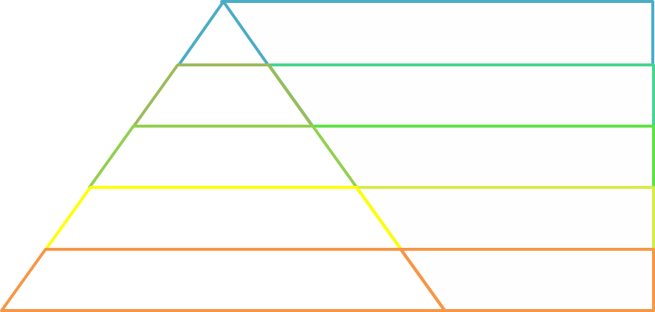

Self-actualisation

Esteem

Love and belonging

Safety needs

Physiological needs

Achieving one’s full potential, creativity, etc.

Self-esteem, self-confidence, respect from others, sense of achievement, etc.

Sense of belonging, friendship, love, etc.

Sense of security, stability, etc.

Food, water, air, sleep, etc.

**Fig. 2 Maslow’s hierarchy of needs**

Source: 宗文舉、石鳳妍、詹啟生 (2017), 《現代心理學理論與實踐》.

**Activity 1: The self-esteem scale**

The following quiz will help you understand your self-esteem level. Read the following sentences carefully and answer honestly.

Do you agree with the following descriptions of yourself? Please tick “✓” the appropriate boxes.

|  |  |  |  |  |
| --- | --- | --- | --- | --- |
| Description | Strongly disagree | Disagree | Agree | Strongly agree |
| 1. When I am praised, I will take it well. |  |  |  |  |
| 1. Sometimes I feel I am not good at anything. |  |  |  |  |
| 1. I think I have many strengths. |  |  |  |  |
| 1. I am willing to overcome my weaknesses. |  |  |  |  |
| 1. I do not think I have anything to be proud of. |  |  |  |  |
| 1. Sometimes I feel I am useless. |  |  |  |  |
| 1. I think I am a valuable person, at least as valuable as others. |  |  |  |  |
| 1. I wish I could have more respect for myself. |  |  |  |  |
| 1. I tend to consider myself a loser in many aspects of life. |  |  |  |  |
| 1. On the whole, I'm satisfied with myself. |  |  |  |  |

**Scoring method:**

|  |  |  |  |  |  |  |  |  |  |  |
| --- | --- | --- | --- | --- | --- | --- | --- | --- | --- | --- |
| Description number: | **１** | | **３** | | **４** | | **７** | | **１０** |  |
| ***1 point for strongly disagree; 2 points for disagree; 3 points for agree and 4 points for strongly agree.*** | | | | | | | | | | |
| Point(s) | _____＋ | _____＋ | | _____＋ | | _____＋ | | _____＝ | | **Score（Ａ）：**_____ |
| Description number: | **２** | | **５** | | **６** | | **８** | | **９** |  |
| ***4 point for strongly disagree; 3 points for disagree; 2 points for agree and 1 point for strongly agree.*** | | | | | | | | | | |
| Point(s) | ____＋ | | _____＋ | | _____＋ | | _____＋ | | _____＝ | **Score（Ｂ）：**_____ |
| **Total score（Ａ＋Ｂ）：** | | | | | | | | | |  |

Source: Rosenberg (1965), Society and the adolescent self-image.

**Score interpretation:** This assessment is on a 40-point scale. The higher the total score, the higher the sense of self-esteem.

Note: This assessment is designed to help students get a preliminary understanding of themselves, and the results are **not conclusive data**. If you get high scores on the above aspects, you can think about **whether your sense of self-esteem in other aspects needs to be strengthened.** If you get a low score in this assessment, it means that **your sense of self-esteem in the above aspects needs to be strengthened**. Therefore, this is a good opportunity for you to reflect more deeply on your self-evaluation.

**Activity 2: The factors affecting self-esteem**

The self-esteem of an adolescent will be affected by innate factors, character, family, school, peers and society, etc. Through changes in these factors during one’s growth process, one’s self-esteem will be constantly updated, changed and elevated. In addition, some scholars have pointed out that self-esteem is mainly derived from successful experiences and abilities. That is to say, the number of success and failure experiences will affect the self-esteem of individuals; and the evaluation of others will also help or hinder development of one’s self-esteem. We should first understand how these factors affect self-esteem, and then find out the reasons for our high or low self-esteem and learn to accept ourselves and overcome low self-esteem so as to become a person with higher self-esteem.

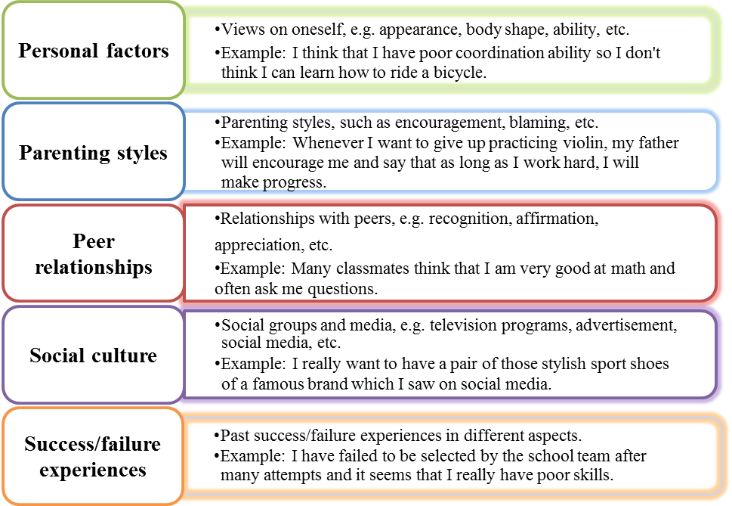

**Fig. 3 The factors affecting self-esteem**

**The factors affecting their self-esteem**

Please complete the task on the next page according to the above contents and the self-narratives of the following characters.

2. I lost the badminton match this time. After that, my parents encouraged me not to give up. I believe that as long as I continue to practice and overcome my weaknesses, I will have a better performance.

1. My classmates criticized my basketball skills. They said that I did not have a clear understanding of myself and blamed me for not quitting the school team sooner. I am really not up to standard.





Shuk Man



Sze Wan

Ming Wah

Mei Wai

Kwok Keung

4. When I went to school this morning, I found that I had forgotten my wallet again. I’m very angry at myself for being so careless all the time.

3. My hairstyle was recommended by many internet celebrities. I always feel that while walking on the street, many people cast envious eyes on me.

5. My skin tone is not as white as Tsz Yu’s, and I don’t have tanned skin tone like Wing Shan. No wonder I am not as popular as them.

How would they evaluate themselves on the aspects mentioned in their self-narratives? What are the factors affecting their self-evaluations? Try to provide answers in the appropriate boxes.

|  |  |  |
| --- | --- | --- |
| **Character** | **Self-evaluation on the aspect mentioned in self-narrative\*** | **Factor influencing self-evaluation** |
| 1. Kwok Keung | ~~high~~/low | *Peer relationships* |
| 1. Shuk Man | high／~~low~~ | *Parenting styles* |
| 1. Ming Wah | high／~~low~~ | *Social culture* |
| 1. Mei Wai | ~~high~~/low | *Failure experiences* |
| 1. Sze Wan | ~~high~~/low | *Personal factors* |

*Delete if not applicable

**Activity 3: Five building blocks of self-esteem**

**The self-esteem theory** of Michele Borba divides self-esteem into five components, namely **security, mission, competence, selfhood and affiliation**. These five components are called the five building blocks of self-esteem. By strengthening these elements, we can be more confident in meeting challenges in life, thus boosting our self-esteem.

**Selfhood**

**Competence**

**Mission**

**Security**

**Affiliation**

* Being aware of one’s strengths; being able to accept one’s weaknesses; willing to learn new things and face challenges.
* Feeling accepted, respected, appreciated and approved by others; having a sense of belongingness; getting along well with others.
* Being aware of one’s uniqueness; sure of one’s self-worth; having a sense of pride.
* Setting personal goals; taking responsibility to put ideas into practice and try new things; willing to make decisions and bear the consequences.
* Trusting others; having a feeling of safety and being protected; do not worry easily.

**Fig. 4 Five building blocks of self-esteem**

Source: Borba (1989), Esteem builders; Shotton & Burton (2018), Emotional wellbeing: An introductory handbook for schools（2nd ed.）.

**Analysing a person’s self-esteem**

**Case 1**

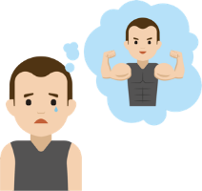I am a very ordinary person and no one ever pays me any attention. My thin body has made me feel inferior. I really want to have a strong body like celebrities. I want to do more exercise to get in shape, but I am not willing to go through the hardship of exercising.

**Kwok Wing**

Besides, I have never participated in school activities, because I feel that my performance will never be as good as others, and I will make a fool of myself and be ridiculed by my classmates. Even though my teacher invited me to be the class monitor and reassured me of my ability, I was still afraid that I would not be able to do the job well, so I declined the teacher’s invitation. Once, I took the initiative to accompany my classmates on piano in a music lesson in order to show my ability to play the piano, but there was no applause or cheering, which made me feel very depressed.

**Case 2**

My performance in singing, ballet and piano is second to none. I believe that I will win the inter school singing competition this year. I am pretty and will be a very popular performer in the future. My classmates should be very envious of my achievements and admire me. But I wonder why my classmates do not like to be my friends. Once I heard my classmates say that I was arrogant and liked showing off and I was the teacher’s pet. Therefore, I am very unhappy.

**Mei Hing**

1. What are the differences between Kwok Wing and Mei Hing in the 5 building blocks of their self-esteem? How many points will you give them?

Please colour to grade on a scale of 1to 5 and illustrate your grading with examples.

**Kwok Wing**

|  |  |  |
| --- | --- | --- |
| **Building blocks of self-esteem** | **Points**  *For example:* | **Examples**  *For example:* |
| **Security** |  | * *Although the teacher reassured him of his ability, he was still afraid that he would not be able to do the job of class monitor well.* |
| **Mission** |  | * *Although he wants to do more exercise, he is not willing to bear the hardship of exercising.* |
| **Competence** |  | * *He has never participated in any school activities for fear of poor performance and being ridiculed by his classmates. Also, he declined the teacher’s invitation.* |
| **Selfhood** |  | * *He thinks that he is a very ordinary person. He also feels inferior to others because of his thin body.* |
| **Affiliation** |  | * *He thought that his classmates didn’t like him and gave no response to his performance.* |

**Mei Hing**

|  |  |  |
| --- | --- | --- |
| **Building blocks of self-esteem** | **Points**  *For example:* | **Examples**  *For example:* |
| **Security** |  | * *She was very worried when she heard her classmates spoke ill of her.* |
| **Mission** |  | * *She believes that she will win the inter school singing competition and become a popular artist.* |
| **Competence** |  | * *Her singing, ballet and piano performance are better than others. She has confidence that she will win the inter school singing competition.* |
| **Selfhood** |  | * *She thinks that she is talented and pretty looking.* |
| **Affiliation** |  | * *Her classmates don’t want to be her friends and they will speak ill of her behind her back.* |

Please refer to the above cases and provide your personal views in answering the following questions:

1. Try to choose one person, Kwok Wing or Mei Hing. Describe his/her self-esteem and give examples to support your views.

|  |
| --- |
| *Kwok Wing:*   * *His senses of security, competence, selfhood and affiliation get low grades; and his* *sense of mission gets a medium grade.* * *He thought that he was a very ordinary person and felt inferior about his thin body (selfhood). He lacked self-confidence and declined the invitation to be class monitor (security, competence). Besides, he was very depressed when his classmates did not applaud or cheer to show appreciation of his piano accompaniment (affiliation).* * *But he wanted to do more exercise to get in shape (mission).*   *Mei Hing:*   * *Her senses of mission, competence and selfhood get high grades; and her senses of security and affiliation get low grades.* * *She thought that her performance in singing, ballet and piano was the best (mission, competence), and her classmates should be envious of her and appreciate her talents. She thought that she looked pretty and would be a popular performer in the future (selfhood).* * *But she was not sure why her classmates didn’t like to be her friends (security, affiliation).* |

1. Comparing Kwok Wing and Mei Hing, who has lower self-esteem? In what aspects does he/she need to improve? How to improve his/her self-esteem?

|  |
| --- |
| *Comparatively, Kwok Wing has lower self-esteem.*   * *He should learn to accept himself and appreciate his strengths (such as playing the piano), instead of focusing too much on his figure or how others will think about his appearance.* * *He can also try to accept responsibilities and new challenges (such as being the class monitor) to improve his sense of competence.* * *He can connect with his classmates more often to understand their impression and evaluation of him and to help others in need with his strengths, in order to establish good interpersonal relationships.* |

1. Comparing Kwok Wing and Mei Hing, who has higher self-esteem? In what aspects does he/she need to improve? How to improve his/her self-esteem?

|  |
| --- |
| *Comparatively, Mei Hing has higher self-esteem.*   * *She should learn to be modest and not to be arrogant.* * *She should review herself to see if she has looked down upon others or has forced others to accommodate her preferences. If so, she needs to learn to respect others and show kindness actively, in order to improve her relationship with her classmates.* |

**Summary**

Self-esteem is very important to personal growth. When a person has a healthy self-esteem, he/she will develop a positive attitude towards life. He/she can give full play to his/her strengths, make good use of his/her potential and pursue a more fulfilling life. Development of self-esteem is a continuous process and a person’s self-esteem will change with time. Self-esteem is affected by different factors, such as previous success or failure experiences, words of affirmation from peers and teachers, parenting styles and so on. Therefore, during the growth process, we need to adjust our mindset, and build and maintain positive self-esteem.

The level of self-esteem will influence our physical and mental health, our responses to situations and our attitudes towards others’ evaluations of ourselves. People who over-value themselves tend to be arrogant. They will feel jealous about others’ successes. They are less flexible and find it hard to adapt to change, and they have poor people skills. On the contrary, people who think less of themselves will lack enterprising spirit and always feel inferior to others. They often feel timid, inferior and pessimistic. When they are being criticized, they will feel frustrated and become unable to complete tasks with efficiency. Therefore, we should learn to make accurate evaluations of ourselves. We should have confidence in ourselves and have courage to overcome various difficulties and become better persons. We should refer to the “five building blocks of self-esteem”, namely security, mission, competence, selfhood and affiliation, to cultivate and elevate our self-esteem.

 “3-minute Concept” animated video clip “Self-esteem and Self-confidence”

https://www.edb.gov.hk/en/curriculum-development/kla/pshe/references-and-resources/life-and-society/3-min-concept.html

**Worksheet 4: The importance of self-confidence for personal growth**

**Self-confidence** is about **believing that you can deal with things**. People with high self-confidence will affirm and appreciate their abilities and have higher self-esteem. On the contrary, people with low self-confidence will have a lot of dissatisfaction, make negative self-evaluations, and have lower self-esteem. Self-confidence plays a positive role in the growth process of a person and is an important psychological quality that affects the success of a person. People who lack self-confidence will easily feel inferior and will rely on the affirmation and approval of others when establishing self-confidence. They will become pessimistic and negative because they are afraid of facing criticism from others. On the contrary, some people may become arrogant and tend to overestimate themselves because they are overconfident. They think that they can do what others cannot do, look down on others and cannot get along well with others. In the face of failure, because they are reluctant to admit their mistakes, they tend to evade their responsibilities and shift the blame to others.

To be a confident person, first, we should fully understand ourselves, appreciate and affirm our abilities and strengths. Second, we should be humble and learn to enhance our knowledge and abilities, and face failure and setbacks with a positive attitude. Only by doing so can we become a person with self-confidence.

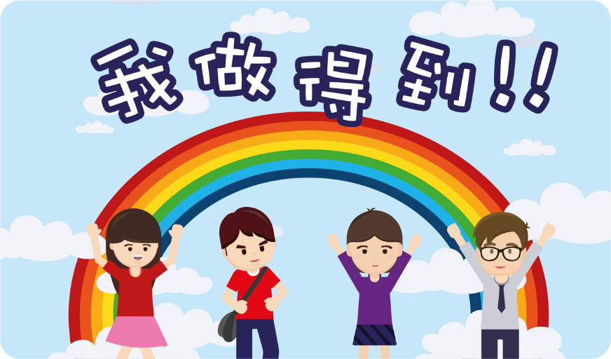

I can do it!!

**Activity 1: “Positivity” and confidence**

Positive thoughts, emotions and behaviours are very important because they can boost our self-confidence. If we have positive ideas, hold a positive and optimistic attitude, and believe in our abilities, we will be more confident in facing the challenges of life and overcoming difficulties.

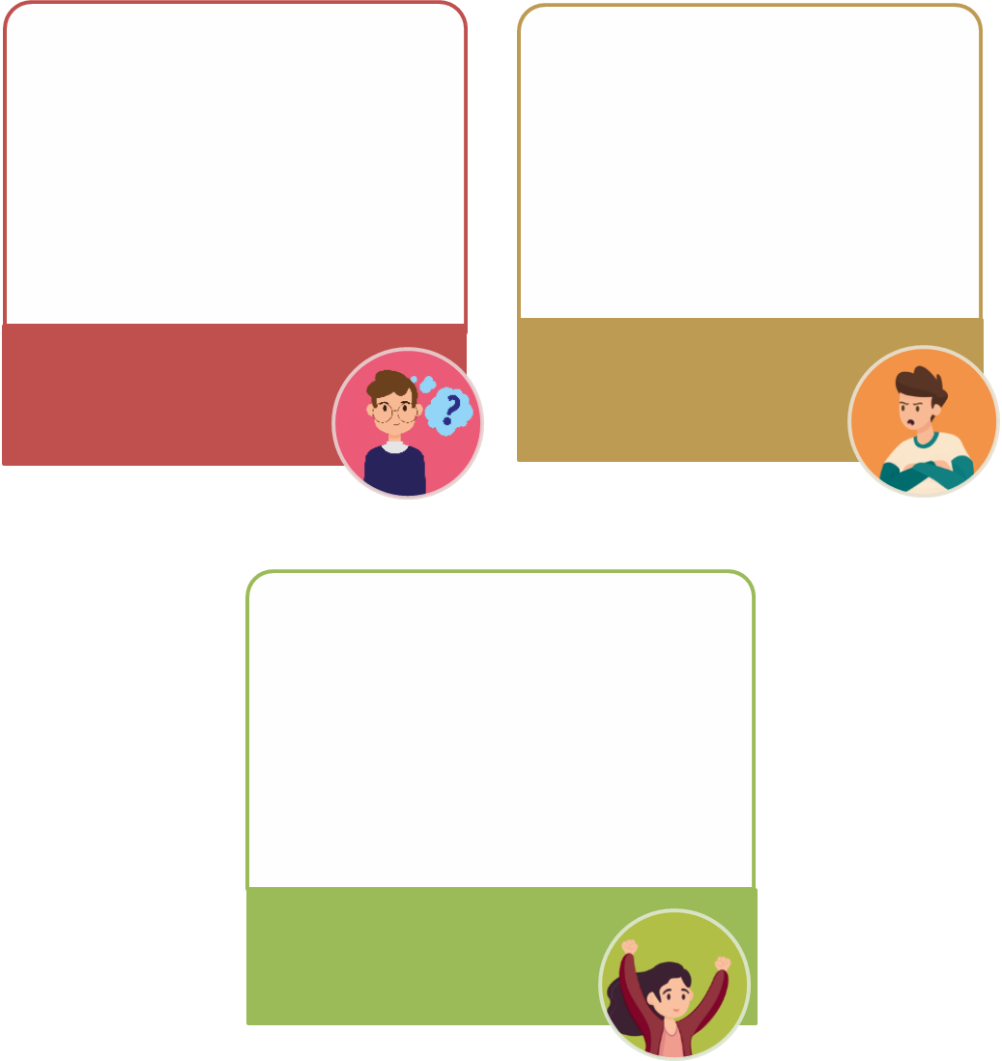

**Positive**

* Be willing to accept and face difficulties
* Try your best to solve problems
* Stick to your goals

**Positive**

* Think of yourself as capable and valuable
* Believe in your ability to overcome difficulties

**Positive**

* Face failure with perseverance
* Be optimistic and positive

**Negative**

* Be frustrated when you fail
* Be pessimistic and negative

**Negative**

* Think of yourself as incapable and valueless
* Think that you can’t solve problems no matter how hard you try

**Negative**

* Run away from difficulties
* Avoid problems or even shift problems to others
* Be half-hearted

Thoughts

Emotions

Behaviours

**Fig. 5 “Positivity” and confidence**

**Activity 2: Notice on “jobs well done”**

../../../Users/patrick/Desktop/螢幕快照%202019-12-23%20下The teacher may use electronic applications like “Word Clouds” to display the experience of the whole class so that students can know the experience of their classmates.



**Notice**

***Jobs well done***

By recording success experiences, we can know more specifically that we were able to accomplish various things, which can remind and encourage ourselves and enhance our self-confidence when we encounter challenges or difficulties in the future. In our spare time, we can also review our successes with the records so that we can cheer ourselves up from time to time and build our self-confidence.

Try to write down **five things that you have done well or success experiences** in the heart-shaped patterns below. For example, I was praised by the teacher for my sense of responsibility; I participated in volunteer service and provided materials for the elderly living alone; I was elected as little pioneer of environmental protection in 6th grade in primary school.





**Know more: The bank of “confidence"**

Appendix 4

**Tips for enhancing self-confidence**

**Method 1: To live in the future**

The Chinese physicist WAN Weigang（萬維鋼）once remarked, “Success is the mother of success”. WAN Weigang thought that if we wanted to increase our chance of success, we must “**live in the future**”. “**Living in the future**” refers to **thinking over the things to be done in mind,** which includes **thinking about what needs to be prepared in advance, the difficulties that may be encountered** and **how to do things well**. Doing things with such an attitude will definitely cultivate our habits of thinking and careful planning. A cautious attitude will certainly improve others’ trust and confidence in you, and when you get the trust of others, you will also have higher self-confidence.



**Method 2: To record success experiences**

Any small success can give people a sense of achievement and build up self-confidence. Daniel Kahneman, a laureate of the Nobel Prize for Economics in 2002, found that “Compared with people’s memory of success, that of failure is more vivid”. Even if the number of times of success and failure are almost the same, we will still subconsciously think that life is full of failure over time. Therefore, Kahneman suggested that we should **record our experiences of success** every day and make **a growth diary**, with which we can not only witness our success but also affirm ourselves.

**Method 3: To generate positive energy with body gestures**

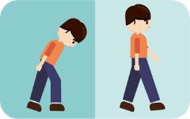Social psychologists Stepper and Strack found that the actions of “lowering the head, shrugging and bending down” would leave people with an impression of dejection on you. However, if you straighten your back and hold your head high, you will leave people with an impression of great aspiration. These body gestures affect your level of pride. People with **self-confidence** will **hold their heads high and their backs straight** and will **walk 30%** faster than the speed of ordinary people and **have a high level of pride**. Therefore, we should always keep a gesture of great aspiration so as to generate positive energy and build up self-confidence.

**Method 4: To learn more and experience more**

During the process of learning new knowledge and skills, we will unconsciously **develop a sense of superiority** due to **the enrichment of our personal knowledge and ability**. After **repeated practice and the accumulation** of certain experiences of success, our **self-confidence** will be gradually enhanced. At the same time, we should make more **new attempts** or travel to different places to **broaden our horizons, knowledge and experiences**, all of which will boost our self-confidence.

Excerpted and adapted from: 速溶綜合研究所，何聖君（2018）, 《超實用博

弈必勝書》.

**Be a person with self-esteem and self-confidence**

Self-confidence can bring positive energy, make us stand out, enable us to do things with more confidence and motivation and help us embark on a road to success. But what can you do to be confident? Do you think you are a confident person? The suggestions in the chart below may help you further build your self-confidence, appreciate your strengths, accept and overcome your weaknesses so that you can cherish yourself.

**Fig. 6 Methods to cultivate self-esteem and self-confidence**

Excerpted and adapted from: Student Health Service, Department of Health, The Government of the Hong Kong Special Administrative Region (10 December 2015), Psychosocial Health.

**Summary**

Everyone is unique and has his/her own qualities and talents. Every one of us is valuable if we can give full play to our strengths and contribute ourselves. Although it is a long and ongoing process to know ourselves, it is not out of reach. We can learn about our “true self”, “ideal self” and “self in the eyes of others” through various ways. For example, we can observe people’s behaviours in group situations, be honest with ourselves and others, accept our “true self” and others’ views on us calmly, understand ourselves in an objective and comprehensive way, and be willing to try and learn new things. If we close our minds for fear of failure, we will become stagnant. On the contrary, if we have the courage to try and learn new things, we will have new discoveries and acquire new understanding, and develop a better understanding of ourselves.

Self-understanding will change over time. Our views on ourselves will be affected by new experiences in life, affirmations, or evaluations from others, as well as success or failure experiences. We may not be satisfied with the present. However, ｗe should understand that there is no such thing as a perfect person in this world. Therefore, we do not have to try so hard to look perfect all the time in front of others. We should learn to appreciate our talents and accept our limitations, because that is exactly the perfect condition of our self-esteem and self-confidence. As long as you can hold this positive attitude towards yourself, keep modest and learn from others, and improve yourself, it is believed that in the near future, you will become a better person.

No matter what you want to do in the future, you must learn to know yourself, explore your potential and strengths through self-exploration, think about your direction and goals in life and find your own way. In this complex and changeable society, the more you know yourself, the clearer you are about your position so that you can adjust your mind flexibly and choose a suitable arena where your special talents and qualities will shine. You should be brave to accept challenges and at the same time build harmonious interpersonal relationships. Together, it will help you actualise your potential and find a life that belongs to you.

Module 1.1 Self-understanding and Life Skills Part 2 “Emotion Management and Resilience Enhancement” will help us understand emotions and different methods and skills of emotion management, which will improve our life skills to meet practical needs in daily life.



**Joyful Reading**

Appendix 5

**Stories of famous people**

**Story 1: Appreciating yourself is the first step to success**

A poor young man with almost no strength came to Paris. He expected that a friend of his father could find him a job to make a living. But when his father's friend asked him a few questions about his strength, the young man could only shake his head shyly and tell him – it seemed like that I did not have any strength, not even a little bit.

His father's friend asked him to write down his address. The young man wrote down the address in shame and left in a hurry. When he turned around, he was pulled by his father's friend who said, “Young man, your signature is very beautiful. That is your strength! You shouldn’t be content with finding a job to live on.” How could the ability of writing one’s name beautifully be a strength? But in the eyes of his father's friend, the young man saw affirmation, so he said: “Ah! I can be praised because of my beautiful signature. If I can write beautifully, then I must have the ability to write good articles!”. The young man who was encouraged amplified his own strength bit by bit and walked briskly away.

A few years later, the young man wrote world-famous classic works as expected. And he is the famous French writer Alexandre Dumas.

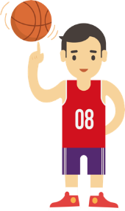

**Story 2: Trust yourself and nothing is impossible.**

At 5 feet 3 inches tall, Tyrone Curtis Bogues, also known as Muggsy Bogues, nicknamed Muggsy, was the shortest player in the history of the NBA. Bogues had loved basketball very much since he was a child, and at that time, he dreamed of joining the NBA team one day. But when his peers knew about it, they could not help laughing. They laughed so hard that some even fell to the ground. They all thought that “a dwarf with a height of only 1.60 meters is ‘a natural disaster’ and it is ‘absolutely impossible’ for him to join the NBA”.

However, the words “absolutely impossible” did not extinguish Bogues’ ambition. He believed that as long as he worked hard, he would succeed. Therefore, he spent more than ten times of time on training than others to improve his skills. He made full use of his advantages of small body size and the characteristics of flexible and quick action and became an all-round basketball player and a best point guard in the end. Bogues succeeded because he believed in himself and turned his disadvantages into his advantages with his strong will and active enterprising spirit.

Excerpted and adapted from: mingyanjiaju.org (undated), 《勵志小故事》.

Reflective questions:

1. Which character do you think is more enlightening to you? Why? In what ways does he inspire you?
2. What is the best thing you can get from reading others’ stories?

If you are interested in reading more life stories of others, you can look for more interesting and enlightening stories from books or search them on the Internet.



Self-learning materials

**Self-learning material 1: Three characteristics of self-concept**

**Three characteristics of self-concept**

1. **Subjectivity:** Since self-concept is formed by one’s own opinions, it is subjective.
2. **Changeability:** As we grow up, gain more experiences in life, and have more interaction with others, our self-concept can be influenced by events and changed. Therefore, self-concept is changeable.
3. **Malleability:** Evaluations from others will prompt us to re-examine ourselves and adjust our views on ourselves (self-concept) in order to help us move closer to our “ideal self”. Therefore, self-concept is not stable, but malleable.

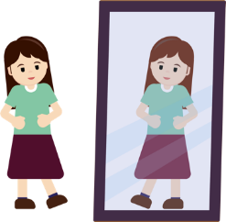On the whole, self-concept is what you think of yourself. We all have fixed views on ourselves in some respects, such as appearance and preferences (subjectivity). However, due to factors such as various growth experiences, evaluations of relatives and friends and mainstream values of society, we change our self-concept gradually (changeability). Also, we will adjust or shape our self-concept based on new understanding of ourselves and take actions for improvement, in order to reduce the differences between the “true self” and “ideal self” and achieve our goals (malleability).

**Activity**

Please refer to the three characteristics of self-concept and continue the story below and answer the questions on the next page.

* + - 1. Please read the story of Ho Fai carefully and then write an ending for his story.



The story of Ho Fai

In primary school, Ho Fai considered himself an excellent student. He always memorized all the contents of textbooks thoroughly before exams, so he was the top student in class all the time. However, in middle school, he always failed to get good grades. Therefore, he began to feel confused and uncertain. He even denied that he had problems in his study. Instead, he thought that his teachers had graded him unfairly.

Later, Ho Fai decided to ask a senior student how to solve this problem. She told him that the learning methods in middle school were different, and he needed to have a thorough understanding of what he had learned to get good grades. He could not learn merely by memorizing the contents without understanding.

After listening to her advice, Ho Fai found that he only had a good memory but knew little about learning. This is Ho Fai’s new understanding about himself. But since he had always wanted to be an excellent student, he didn’t want to give up.



**The ending of the story of Ho Fai**

What do you think Ho Fai should do next? Try to write an ending for Ho Fai’s story.

The Story of Ho Fai (the end)

*For example:*

*Ho Fai understood that learning by memorization was not suitable for middle school and the best way to learn was to gain a thorough understanding of the contents. Therefore, he decided to change his method of studying. He decided to try more new methods and ask more questions. When he encountered questions that he could not understand, he would look for answers on the Internet, or look up books in the library, or consult his classmates and teachers. In addition, he would try to improve his self-value and explore new knowledge during his spare time. He hoped that he could solve learning problems using different methods and become a better student.*



Questions for discussion:

1. Can you point out the three characteristics of self-concept?

|  |
| --- |
| *The three characteristics of self-concept are subjectivity, changeability and malleability.* |

1. Please take Ho Fai as an example to explain one of the characteristics of self-concept.

|  |
| --- |
| *For example:*   * *Subjectivity: Ho Fai considered himself an excellent student since he could memorise all the contents of textbooks thoroughly and was the top student in class all the time.* * *Changeability: After listening to the advice of a senior student, Ho Fai found that he only had a good memory but knew little about learning. He gained a new understanding of himself after listening to others’ views.* * *Malleability: Based on others’ views, Ho Fai adjusted his views on himself and on what it took to become an excellent student. He then took action to improve his method of studying to focus on gaining a thorough understanding of the contents. This shows Ho Fai’s views on himself is not stable but can be adjusted or shaped to help him move closer to his goal.* |

**Self-learning material 2: The formation of self-concept**

We have learned about what self-concept is from Worksheet 2 and Self-learning material 1, but how is self-concept formed?

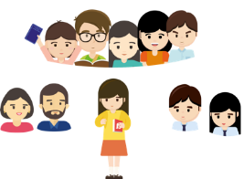

Self-concept is formed gradually after a person was born. Firstly, he/she will discover that he/she is different from others, and then gradually understand how he/she is different from others. We seek understanding of ourselves through interaction with others. In different stages of life, the formation of our self-concept will be affected by different people, conditions and events, such as our parents, relatives, classmates, friends, social groups, family background, education, religious belief, ethnic culture and so on. Besides, we play different roles in society (such as an elder sister, a student, etc.) and act according to the expected behaviours of different roles.

At different stages of our growth, there are different people who are considered important by us. For example, children of 0-6 years may be greatly influenced by comments from their parents. If they get praised by their parents for their good grades, they will gradually think that they are smart. When they reach 6-12 years old, besides their parents, they begin to come into contact with all kinds of people and new things. Such experiences will build and change their self-concepts. For example, a cartoon character may become their role model which will motivate them to improve themselves. When they reach adolescence around the age of 12-18 years old, they need to be recognised and accepted. Peer evaluations have a far-reaching impact on their self-concepts.

|  |  |  |
| --- | --- | --- |
| Age | Stage | People who have the greatest influence |
| 0-6 years old | Early childhood | Affected by **parents**  Example 1: I was praised by my parents because of my good exam results.  Example 2: I was blamed by my parents for not doing well in the exam. |
| 6-12 years old | Childhood | Affected by **important people**, such as parents, grandparents, teachers, friends, neighbours, movie stars, celebrities, cartoon characters, etc.  Example 1: I was praised by the teacher for answering questions actively in class.  Example 2: I was blamed by the teacher for avoiding answering questions in class |

|  |  |  |
| --- | --- | --- |
| Age | Stage | People who have the greatest influence |
| 12-18 years old | Adolescence | Affected by **peers**  Example 1: I was praised by my classmates for participating in volunteer service on Saturday.  Example 2: My classmates said I was selfish because I was unable to go back to school to do voluntary work on Saturday. |

Reflective question:

1. Who/what factor has the greatest influence on your self-concept? Explain your answer with examples.

|  |
| --- |
| *For example:*  *I think my self-concept is greatly influenced by my teachers and peers. It is because I care much about what they think of me. Their evaluations allow me to know my strengths and weaknesses that I have not paid attention to so that I can understand myself better.* |

**Self-learning material 3: Knowing “my” self-concept**

**Self-concept quiz**

It is important for teenagers to have a clear self-concept because it affects self-confidence and self-esteem. The following quiz will help you understand your self-concept. Read the following sentences carefully and circle your answers honestly. Responses are scored on a 5-point scale with a score of 5 representing “totally agree” and 1 representing “totally disagree”.

|  |  |  |  |  |  |
| --- | --- | --- | --- | --- | --- |
| Statement | Totally disagree | Mostly disagree | Partly agree | Mostly agree | Totally agree |
| 1. I’m satisfied with my appearance. | 1 | 2 | 3 | 4 | 5 |
| 1. I get on well with my classmates. | 1 | 2 | 3 | 4 | 5 |
| 1. I often think that my life is very good. | 1 | 2 | 3 | 4 | 5 |
| 1. I am satisfied with my academic achievements. | 1 | 2 | 3 | 4 | 5 |
| 1. I have a good relationship with my family. | 1 | 2 | 3 | 4 | 5 |
| 1. I try my best to be filial to my parents. | 1 | 2 | 3 | 4 | 5 |
| 1. I think that I have dreams and aspirations. | 1 | 2 | 3 | 4 | 5 |
| 1. I’m of medium build. | 1 | 2 | 3 | 4 | 5 |
| 1. I think that I am a firm person and will not be tempted to do bad things. | 1 | 2 | 3 | 4 | 5 |
| 1. I’m a person of my word. | 1 | 2 | 3 | 4 | 5 |

**Total score: ____________**

Source: 莊榮俊 (2002), 《國中學生自我概念、生活適應與自我傷害關係之研究》.

**Scoring method:** Please add up your score for each of the statements to get the total score. The lowest total score is 10 points and the highest total score is 50 points.

**Score interpretation:** **The higher the score is**, **the more satisfied** you are with yourself, and you have more **positive** thoughts and attitudes on yourself. That is to say, you have a positive self-concept.

Note:

The above quiz is designated for us to know ourselves from different aspects. And the quiz is **neither rigorous nor precise** and the results are **for reference only**. We don’t need to and **should not** consider it as **a rigorous standard assessment tool** for self-concept. If you get **high scores** in all the above statements, you can think about how to **continue to improve your positive self-concept**. If you get a **low score** in this quiz, it means that your self-concept in some of the aspects **need to be improved with more positive thoughts and attitudes**. Therefore, this is a good opportunity for you to reflect on your views on yourself.

|  |
| --- |
| Generally speaking, if we have a positive self-concept (feeling “satisfied” with ourselves), we will have greater self-confidence and higher self-esteem. No matter what we encounter, we can face it with a positive and active attitude. Therefore, it will be easier for us to achieve good results. On the contrary, if our self-concept is relatively negative (feeling “dissatisfied” with ourselves), we will lack self-confidence and have low self-esteem, resist facing and accepting ourselves, doubt our value of existence, feel confused and troubled and even hate ourselves.  In fact, as long as we appreciate our strengths, strive to overcome our shortcomings and accept our limitations, we can also have a positive self-concept. |

Reflective questions:

1. Have you learned more about yourself after completing the “self-concept quiz”? Please give one example.

|  |
| --- |
| *For example:*   * *Yes, I have. I understand that I need to develop a more positive attitude towards my physical appearance.* * *No.* |

1. How can we improve our self-concept?

|  |
| --- |
| *For example:*   * *I can seek the opinions of parents, teachers and/or classmates and accept their suggestions to proactively improve myself.* |

**References**

王淑俐（2016）。《生涯發展與規劃：為職涯發展做準備》（第三版）。台北：揚智文化。

宋康（2013）。《凡高自畫像、義大利女人》。中國：江西美術。

李珊（2016）。《做一個內心豁達的女人》。中國：中華工商。

宗文舉、石鳳妍、詹啟生（2017）。《現代心理學理論與實踐》。台北：崧博。

長江文藝出版社（1982）。《藝叢》，2-4，124。

Student Health Service, Department of Health, The Government of the Hong Kong Special Administrative Region (10 November 2015). Psychosocial Health. <https://www.studenthealth.gov.hk/tc_chi/health/health_ph/health_ph_young.html>

馬貝（2018）。《繪畫大師達文西》，台北：千華駐。

速溶綜合研究所、何聖君（2018）。《超實用博弈必勝書》。香港：非凡。

莊榮俊（2002）。《國中學生自我概念、生活適應與自我傷害關係之研究》（未出版博士論文）。南華大學。臺北。

Borba, M.（1989）. *Esteem builders*. Rolling Hills Estates, CA: Jalmar Press.

mingyanjiaju.org (undated).《勵志小故事》.   
<https://mingyanjiaju.org/lizhixiaogushi/>

Education Bureau, the government of the Hong Kong Special Administrative Region (2022). “Self-concept” in *“3-minute Concept” animated video clip series*.   
https://www.edb.gov.hk/en/curriculum-development/kla/pshe/references-and-resources/life-and-society/3-min-concept.html

Education Bureau, the government of the Hong Kong Special Administrative Region (2019). “Self-esteem and Self-confidence” in *“3-minute Concept” animated video clip series*.   
https://www.edb.gov.hk/en/curriculum-development/kla/pshe/references-and-resources/life-and-society/3-min-concept.html

Newman, B. M., & Newman, P. R.（2017）. *Development through life: A psychosocial approach*（13th ed.）. Boston, MA: Cengage Learning.

Rosenberg, M.（1965）. *Society and the adolescent self-image*. Princeton, NJ: Princeton University Press.

Shotton, G., & Burton, S.（2018）. *Emotional wellbeing: An introductory handbook for schools*（2nd ed.）. London: Routledge.

**(Blank Page)**

